

**Capstone Project Final Report**

**Project title: Social Fashion Network (SOFA)**

**Hanoi, May 6th, 2021**

**Table of Contents**

Chapter 1: **Introduction**

1. **Purpose**

This chapter provides an overview of the project including background information, a literature review of the existing system, and raising a proposal for ideas of improvement.

1. **Project Information**

* Project name: **SOFA – Fashion Social Network**
* Project code: **SOFA**
* Project group name: **SWP490_G22**
* Product type: **Mobile Application – Android**

1. **Project Team**

### Supervisor

|  |  |  |  |  |
| --- | --- | --- | --- | --- |
|  | **Full name** | **Phone** | **E-mail** | **Title** |
| Supervisor | Phạm Ngọc Hà | 0988623000 | [hapn10](mailto:hapn10)@fpt.edu.vn | Lecturer |

### Team Members

|  |  |  |  |  |  |
| --- | --- | --- | --- | --- | --- |
| **No.** | **Full name** | **Student ID** | **Phone** | **E-mail** | **Role** |
| 1 | Lê Thiện Văn | HE130820 | 0375956599 | vanLTHE130820@fpt.edu.vn | Leader |
| 2 | Nguyễn Huy Hoàng | HE130395 | 0355517865 | hoangNHHE130395@fpt.edu.vn | Document Lead |
| 3 | Hà Việt Dũng | HE130952 | 0942561863 | dungHVHE130952@fpt.edu.vn | Member |
| 4 | Mai Văn Viên | SE05783 | 0969614666 | vienMVSE05783@fpt.edu.vn | Test Lead |
| 5 | Nguyễn Thanh Tùng | SE05590 | 0344261997 | tungNTSE05590@fpt.edu.vn | Member |

1. **Background**

Today, in a developing age, living conditions are getting higher and higher. Eat well and dress well instead of eating fully and dressing warmly. Fashion is almost indispensable for every person. Fashion tells almost everything about a person, helps a person more beautiful, and makes someone confident. But not all people know how to choose clothes which are suitable for them. To resolve this problem, we develop a system that allows users to share their dress styles and suggest them to other users. So, thanks to this system every people could choose suitable clothes and dress style.

1. **Literature review of the existing system**
   1. Dress As

The fashion social network for women. This app can be downloaded on Google Play.



|  |  |  |
| --- | --- | --- |
| **Advantages** | **Disadvantages** | **Compare with SOFA** |
| GUI simple, modern | Just for women | For everybody |
| Easy to share a personal image | Simply an app to share images and search for related products, with little social network direction | A social network allows interaction between users more than the existed app (Can chat, add friend, comment…) |
| Can search for similar products by image | Don’t allow write the caption for an image, don’t allow share post | Allow write the caption, interaction, comment, share |
|  | Don’t have feature fashion trending | Have feature fashion trending |
|  | Don’t have feature suggest style and clothes for the user | Based on user's data along with fashion style then suggest style and clothes for the post who have similar data |
|  | There isn't feature posts featured based on interactions, posts of KOL | Have feature posts featured based on interactions, posts of KOL |
|  | There isn’t suggest where a user can buy the product. Search product restricted products on the asos.com website | Suggest where a user can buy the product. Not restricted search product. |
|  | User are those who want to share pictures of fashion, do not have shop features | Have a feature for seller and shop |

* 1. Fashion Tap



|  |  |  |
| --- | --- | --- |
| **Advantages** | **Disadvantages** | **Compare with SOFA** |
| Allows users to insert links on each item in the photo leading to the place of sale | The system still has many errors. For example, the image cropping feature after the upload is still faulty |  |
| Can import photos from Instagram to FashionTap | Simply an app to share images, with little social network direction | The social network allows interaction between users more than the existed app (Can chat, add friend, comment…) |
| After uploading photos, you can use the system's tools to edit the photos before posting | Don’t have feature fashion trending | Have feature fashion trending |
| Allows users to share post to other social networking | Don’t have feature suggest style and clothes for the user | Based on user's data along with fashion style then suggest style and clothes for other users who have similar data |
| Can report post with bad content | There isn't feature posts featured based on interactions, posts of KOL | Have feature posts featured based on interactions, posts of KOL |
| Can review all product about fashion include clothes, cosmetics, accessories fashion | Don’t have a feature rating for the post | User can rate post that shows the quality of the post |
| Have feature ask and answer |  |  |

## Smart Fashion





|  |  |  |
| --- | --- | --- |
| **Advantages** | **Disadvantages** | **Compare with SOFA** |
| User can try clothes on a virtual model (Use deep-learning to simulate clothing and try on a virtual model) | focus on features buy, trial, and sell, so it does not attract a large number of users. | User can post, share their image, chat and add friend with other people |
| Can search product by scan QR code | Don't have interaction between users | Social network allows interaction between users more than the existed app (Can chat, add friend, comment…) |
| Can create an event (make user interest app) | Don’t have feature fashion trending | Have feature fashion trending |
| Have a feature for seller and shop | Don’t have feature suggest style and clothes for the user | Based on user's data along with fashion style then suggest style and clothes for other users who have similar data |
| User can save the product that they like | The system still has many errors. |  |

1. **Business Opportunity**

Today, the problem about choose fashion style and clothes are hot, besides that linking between shop and customer is very important. So, it's a good opportunity for fashion social networking and suggests a fashion system to develop.

However, the User's need and the shop's need are not similar. Shop wants to customer know about their product. People want to know how to choose style and clothes for themselves and where they can buy that product. So, SOFA will try to solve the problem by the way that allows users to share personal fashion style, suggest for the user the fashion style that suitable for them, and hint user shops where they can buy that product.

SOFA will help the user choose clothes and find clothes, help customers know about the product of shops.

1. **Software Product Vision**

With the applying recommendation system and deep-learning API to suggest clothes and fashion style for user. We want to aim to optimize the operation of the system. We develop a system with a backend is a restful API, frontend for the manager is a website and frontend for user is android app. Mobile app help user feel conveniently and easy to use (for example, user can take a picture, upload picture every time, everywhere). Backend restful API will help us develop frontend for user on other platforms like website, android app...

1. **System Functions**

There are 3 types of users in SOFA system

|  |  |
| --- | --- |
| **Type of User** | **Description** |
| Guest | People who use the system without login. They can only use some basic feature but cannot use advanced feature like create post, like, rate,… |
| User | People who have logged into the system. They can use all of feature of the application. |
| Administrator | People who use management system. They have the most powerful rights in the system such as managing accounts, posts, voucher, feedback,… |

SOFA System provides the following functions:

User:

* *Authentication: login, logout, register, forget password*
* *Post: view list post, view post detail, like post, rate post, comment post, markup post, report post, create post*
* *User Interact: view other’s profile, follow user, report user, message to other user*
* *Message: view conversation list, view a conversation, delete a conversation, create new message, delete a message*
* *Balance: view balance, top up balance, view voucher*
* *Hot: view list hot post, all function like post(User)*
* *Recommend: view list recommend posts, all function like post(User)*
* *Support/Feedback: send feedback, view list feedback, view a feedback’s detail, send support request, view support request’s result*
* *Setting: change password, turn on/off notification, change message theme*
* *Notification: view list notification, view detail notification, mark all as read*
* *Markup post: markup a post, view markup post list, view markup post detail*

Administrator:

* *Account management:* view my profile, change password
* *Feedback management:* view feedback list, search feedback, accept feedback

- *Support management:* view support list, search support, approve support, reject support

- *Voucher management:* view voucher list, search voucher, delete voucher

- *Report management:* view report list

- *User management:* view post list, search post, view post detail, delete post

1. **System Overview**



1. **Out-of-scope functions**

Due to the limitation of time, we will not implement some of the intended functions, although we are aware that they are also important and useful for users of the system:

* Hide post, unhide post
* Share post
* Block user
* Call voice & call video
* Delete comment
* Multiple languages

1. **Tool and technique**

|  |  |
| --- | --- |
| **Category** | **Tools & techniques** |
| **Programming languages** | C#, Python, HTML, CSS, JavaScript, TypeScript |
| **Framework** | ASP.Net core API, Angular 8, React Native, Django |
| **API** | Clarifai, ZaloPay |
| **Third-party** | ZaloPay, Clarifai |
| **DBMS** | SQL Server |
| **IDEs/Editors** | Visual Studio Code, Visual Studio 2019 |
| **UML tools** | Lucid chart, draw.io |
| **Version Control** | Github |
| **Deployment server** | IIS Server (Server machine) |
| **Project management tool** | Trello |

Chapter 2: **Project Plan**

1. **Purpose**

This chapter provides an overview of the project plan, including software process model, project overview, project organization. Moreover, the document also details tools will be used, coding conventions, communication management.

1. **Project Overview**

2.1 Channels

* Application: SOFA Application
* Advertisement:
* Facebook: <https://www.facebook.com/Sofateam2021>
* Youtube: <https://www.youtube.com/watch?v=E7ih7YzWL-8>
  1. Project organization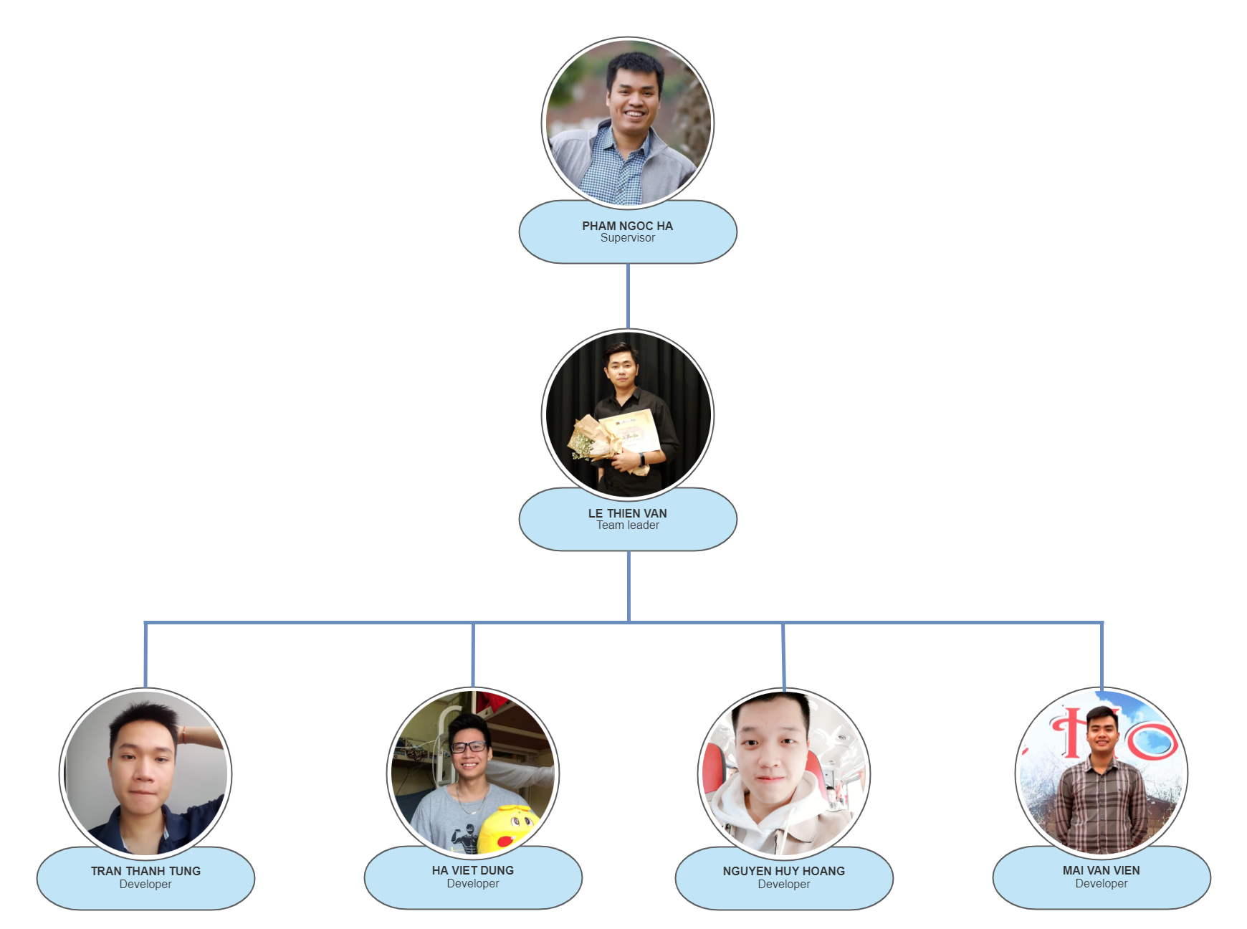
  2. Role and responsibilities

|  |  |
| --- | --- |
| **Team Member** | **Role** |
| Pham Ngoc Ha | Supervisor |
| Le Thien Van |  |
| Nguyen Huy Hoang |  |
| Ha Viet Dung |  |
| Mai Van Vien |  |
| Tran Thanh Tung |  |

* 1. Software process model

1. **Project management Plan**

|  |  |  |  |
| --- | --- | --- | --- |
| **No.** | **WBS Item** | **Complexity** | **Est. Effort (Man-days)** |
| **I** | **SOFA Project** |  | **375** |
| **1** | **Pre-Initiating Phase** |  | **5** |
| 1.1 | Select Project Manager | Simple | 1 |
| 1.2 | Determine the role of team member | Simple | 1 |
| 1.3 | Choose topic | Simple | 2 |
| 1.4 | Register capstone project | Simple | 1 |
| **2** | **Initiating phase** |  | **9** |
| 2.1 | Determine stakeholder | Medium | 1 |
| 2.2 | List up requirement | Simple | 2.5 |
| 2.3 | Define scope of project | Simple | 2.5 |
| 2.4 | Create report 1 - project introduction document | Medium | 2.5 |
| 2.6 | Modify project introduction document | Simple | 0.5 |
| **3** | **Project Plan Phase** |  | **8** |
| 3.1 | Choose working model process | Simple | 2.5 |
| 3.2 | Select tools and techniques | Simple | 0.5 |
| 3.3 | Create project schedule | Simple | 1 |
| 3.4 | Create risk management plan | Medium | 1 |
| 3.5 | Organize project resources | Simple | 2 |
| 3.6 | Create report 2 - software project management plan | Medium | 1 |
| **4** | **Executing Phase** |  | **346** |
| **4.1** | **Design** |  | **59.5** |
| 4.1.1 | List up use case | Simple | 1 |
| 4.1.2 | Create use case description | Medium | 1.5 |
| 4.1.3 | Create report 3 -Software requirement specification | Medium | 5 |
| 4.1.4 | Create Architecture design | Complex | 10 |
| 4.1.4.1 | Data Architecture design | Medium | 2 |
| 4.1.4.2 | Data flow architectures | Medium | 2 |
| 4.1.4.3 | Call and Return architectures | Medium | 2 |
| 4.1.4.4 | Object Oriented architecture | Medium | 2 |
| 4.1.4.5 | Layered architecture | Medium | 2 |
| 4.1.5 | Database design | Medium | 10 |
| 4.1.6 | GUI layout design | Complex | 25 |
| 4.1.7 | Create report 4 - Software design | Simple | 5 |
| 4.1.8 | Redesign use case | Simple | 2 |
| **4.2** | **Implementation** |  | **237** |
| 4.2.1 | Back-end (RESTful API) |  | 92 |
| 4.2.1.1 | Configuration and setup environment | Simple | 2 |
| 4.2.1.2 | Create database | Simple | 15 |
| 4.2.1.3 | Coding common, Middleware, DBContext | Medium | 5 |
| 4.2.1.4 | Coding Model and Data Access Object | Medium | 10 |
| 4.2.1.5 | Coding controller handler request of manager page | Complex | 25 |
| 4.2.1.6 | Coding controller handler request of user app | Complex | 35 |
| 4.2.2 | Front-end |  | 140 |
| 4.2.2.1 | SOFA Manager (Web flatform) | Complex | 40 |
| 4.2.2.2 | SOFA (Android app flatform) | Complex | 100 |
| 4.2.3 | Deploy |  | 5 |
| 4.2.3.1 | Deploy host and domain config | Medium | 5 |
| 4.3 | **Test** |  | **49** |
| 4.3.1 | Test manager website |  | 24 |
| 4.3.1.1 | Create test cases for unit test | Simple | 2 |
| 4.3.1.2 | Unit test | Simple | 2 |
| 4.3.1.3 | Fix bug | Medium | 2 |
| 4.3.1.4 | Create test cases for integration test | Simple | 2 |
| 4.3.1.5 | Integration test | Simple | 2 |
| 4.3.1.6 | Fix bug | Medium | 2 |
| 4.3.1.7 | Create test cases for system test | Simple | 2 |
| 4.3.1.8 | System test | Simple | 2 |
| 4.3.1.9 | Fix bug | Medium | 2 |
| 4.3.1.10 | Create test case for acceptance test | Simple | 2 |
| 4.3.1.11 | Acceptance test | Simple | 2 |
| 4.3.1.12 | Fix bug | Medium | 2 |
| 4.3.2 | Test user application |  | 24 |
| 4.3.2.1 | Create test cases for unit test | Simple | 2 |
| 4.3.2.2 | Unit test | Simple | 2 |
| 4.3.2.3 | Fix bug | Medium | 2 |
| 4.3.2.4 | Create test cases for integration test | Simple | 2 |
| 4.3.2.5 | Integration test | Simple | 2 |
| 4.3.2.6 | Fix bug | Medium | 2 |
| 4.3.2.7 | Create test cases for system test | Simple | 2 |
| 4.3.2.8 | System test | Simple | 2 |
| 4.3.2.9 | Fix bug | Medium | 2 |
| 4.3.2.10 | Create test case for acceptance test | Simple | 2 |
| 4.3.2.11 | Acceptance test | Simple | 2 |
| 4.3.2.12 | Fix bug | Medium | 2 |
| 4.3.3 | Summary and evaluation | Simple | 1 |
| 4.1.9 | Create report 5 - Test case document | Simple | 2.5 |
| 4.1.10 | Create report 6 - Software user guide | Simple | 2.5 |
| **4.4** | **Finish executing phase** |  | **0.5** |
| **5** | **Monitoring and controlling** |  | **2** |
| 5.1 | Progress report | Simple | 2 |
| **6** | **Close** |  | 5 |
| 6.1 | Create final report | Medium | 5 |
| 6.2 | Project complete | Simple | 0 |

1. **Meeting minutes**

|  |  |  |  |  |
| --- | --- | --- | --- | --- |
| **Communication Item** | **Who/ Target** | **Purpose** | **When, Frequency** | **Type, Tool, Method(s)** |
| Weekly meeting | Supervisor and team members | Review members’ work achievements during the week and report the project’s progress and status. | Every Tuesday | Face to face |
| Daily meeting | Team members | Report the progress that members achieved each day. | 21h,  every day | Google meet |
| Unscheduled Meeting | Team members | Occurred when there's a critical problem that need to be resolved immediately |  | Face to face, google meet |

1. **Risk management Plan**

|  |  |  |  |  |  |
| --- | --- | --- | --- | --- | --- |
| **No.** | **Risk** | **Description** | **Impact** | **Possibility** | **Response Plans** |
| 1 | Inaccurate Estimations | Schedule is inaccurate | Medium | Medium | 1) Create schedule carefully 2) Add backup time (or backup schedule) 3) Focus on close targets |
| 2 | Poor Quality Code | The code may be difficult to read, meaning it is difficult for other developers to review or make changes | High | Low | 1) Code reviews 2) Clear coding standards and guides 3) Testing of all code |
| 3 | Inadequate Human Resources | Don't have enough member to complete project be on time | Medium | Low | 1) Register overtime for team member |
| 4 | Technical Difficulties | Have issues during coding | Medium | Medium | 1) Choose design pattern appropriate 2) Create architecture design more detail and exactly 3) Have a professional in team |
| 5 | Security | The system is unsafe for user, hacker can attack and take user information… | High | High | 1) Using token for improving backend security 2) Add more algorithm for hash private information 3) Take preventive measures hacking |
| 6 | Serious error in synchronization between web and mobile platform | display on browser and mobile is more difference. Maybe, the component just can use on web but not mobile | Medium | High | 1) Choose another component to fix 2) Make components difference but similar feature |
| 7 | lack of requirement | Developer create code was not enough requirement | High | Medium | 1) Code reviews 2) Clear coding standards and guides 3) Testing of all code |

1. **Document management Plan**

We use Github as our tool for sharing, editing and version control of our documents, along with Status Reports with-in each document. It allows us to see what is changed in the documents and who is responsible for that change, reverse and simultaneously compare between versions of the document.

1. **Source code management Plan**

For version control of our source code, we use Git hub. It tracks the changes team members make to files, so we have a record of what has been done, and we can revert to specific versions should we ever need to. Github also makes collaboration easier, allowing changes by multiple people to all be merged into one source.

Github also features branches that provide an isolated environment for every change to our codebase. When a team member wants to start working on something - no matter how big or small - he creates a new branch. This ensures that the master branch always contains production - quality code.

Chapter 3: **Software Requirement Specification**

1. **Purpose**

This chapter outlines functional and non-functional requirements of our system. It also provides some format constraints in common requirements and project success criteria. The content of this chapter is used as the basis for the work in the subsequent chapters.

1. **User requirements**
   1. Overview
2. Use case diagram

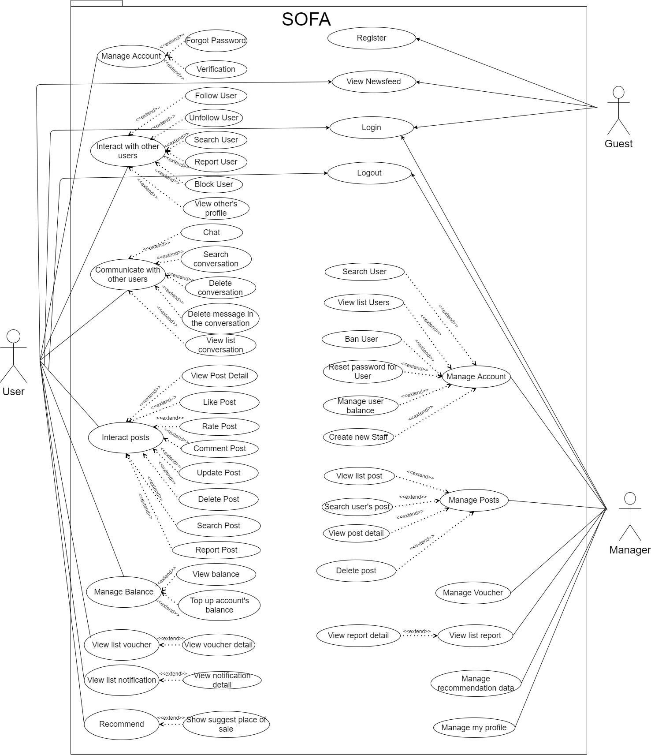

# Detailed Description of Components

Chapter 4: **Detailed Description of Components**

## *System Architecture Design*



*Figure 4.1 – System Architecture Design*

## *Software Architecture Design*

## 

*Figure 4.2 – Software Architecture Design*

## *3. Description of System Interface*

***3. 1. Database management system***

## 

*Database management system*

Database management system is a software which is used to manage the database. For example: SQL Server, MySQL, Oracle, etc. are a very popular commercial database which is used in different applications. DBMS provides an interface to perform various operations like database creation, storing data in it, updating data, creating a table in the database and a lot more. It provides protection and security to the database. In the case of multiple users, it also maintains data consistency.

***3.2. Clarifai***



**Clarifai** is an Image Recognition Software solution highly appreciated by both users and experts in the field of Deep Learning Software.

The platform includes the ability to moderate content, perform visual search, visual similarity, and organize media collections. It has pre-built recognition models that can identify a specific set of concepts like food or travel, NSFW, and its general model which can identify a range of concepts including objects, ideas, and emotion. It also has the ability to create custom models which can identify other arbitrary objects such as cars or breeds of dogs.

***3.3. Zalopay***



ZaloPay is an e-wallet platform and online payment system developed by VNG to deploy in-app payments and scan QR codes for payment on mobile devices, allowing users to do so. transactions using phones and tablets running Android and iOS. For many years (from 2018 to 2020), many channels have been introduced as the top 5 recommended e-wallets in Vietnam

**4. Component Diagram**



## 

## 5. Detailed Description of Component

***5.1. View***



## Class Diagram

***6.1. Class diagram***

***6.1.1. Post Class Diagram***



***6.1.2. Account Class Diagram***



***6.1.3. Profile Class Diagram***



***6.1.4. Notification Class Diagram***



***6.1.5. Message Class Diagram***



***6.2. Models***

***6.2.1 Account***



**Class specification**

|  |  |  |  |
| --- | --- | --- | --- |
| **NO** | **Attribute** | **Type** | **Description** |
| 01 | id | int | ID of account |
| 02 | username | string | User Name of account |
| 03 | password | string | Password of account |
| 04 | isActive | boolean | Status active of account |
| 05 | isBlock | boolean | Status block of account |

|  |  |  |
| --- | --- | --- |
| **NO** | **Method** | **Description** |
| 01 | Account(int iD, string userName, string password, bool isActive, bool isBlock) | Default constructor |
| 02 | Account(DataRow row) | Another constructor |

***6.2.2 AccountLog***



**Class specification**

|  |  |  |  |
| --- | --- | --- | --- |
| **NO** | **Attribute** | **Type** | **Description** |
| 01 | id | int | ID of log |
| 02 | accountID | int | ID of account log |
| 03 | beforeBalance | double | Balance of account before transaction |
| 04 | afterBalance | double | Balance of account after transaction |
| 05 | transactionID | int | ID of transacation |

|  |  |  |
| --- | --- | --- |
| **NO** | **Method** | **Description** |
| 01 | AccountLog(int iD, int accountID, double beforeBalance, double afterBalance, int transactionID) | Default constructor |
| 02 | AccountLog(DataRow row) | Another constructor |

***6.2.3 Comment***



**Class specification**

|  |  |  |  |
| --- | --- | --- | --- |
| **NO** | **Attribute** | **Type** | **Description** |
| 01 | id | int | Id of comment |
| 02 | accountID | int | Id of account comment |
| 03 | postID | int | Id of the post |
| 04 | content | string | Content of the comment |
| 05 | time | DateTime | Time comment is created |

|  |  |  |
| --- | --- | --- |
| **NO** | **Method** | **Description** |
| 01 | Comment(int id, int accountID, int postID, string content, Datetime time) | Default constructor |
| 02 | Comment(DataRow row) | Another constructor |

***6.2.4 Feedback***



**Class specification**

|  |  |  |  |
| --- | --- | --- | --- |
| **NO** | **Attribute** | **Type** | **Description** |
| 01 | id | int | Id of the feedback |
| 02 | title | string | Title of the feedback |
| 03 | content | string | Content of the feedback |
| 04 | userFeedbackId | id | Id of the user have send feedback |
| 05 | lastUpdated | string | The final date update the feedback |
| 06 | status | int | Status of Feedback:   * Status = 1: Resolved * Status = 2: Unresolved * Status = 3: Rejected |

|  |  |  |
| --- | --- | --- |
| **NO** | **Method** | **Description** |
| 01 | Feedback(int id,string title, string content, int userFeedbackId, string lastUpdated, int status) | Default constructor |
| 02 | Feedback(DataRow row) | Another constructor |

***6.2.5 Follow***



**Class specification**

|  |  |  |  |
| --- | --- | --- | --- |
| **NO** | **Attribute** | **Type** | **Description** |
| 01 | relationId | int | Relation of the Following :   * Relation = 1 : Follow * Relation = 2 : Block |
| 02 | followerId | int | Id of the user follow |
| 03 | userGetFollowId | int | Id of the user is followed |

|  |  |  |
| --- | --- | --- |
| **NO** | **Method** | **Description** |
| 01 | Follow() | Default constructor |
| 02 | Follow(int relationId, int followerId, int userGetFollowId) | Another constructor |

***6.2.6 Image***



**Class specification**

|  |  |  |  |
| --- | --- | --- | --- |
| **NO** | **Attribute** | **Type** | **Description** |
| 01 | id | int | Id of the image |
| 02 | postId | int | Id of the post contain the image |
| 03 | url | string | The path to the image file |

|  |  |  |
| --- | --- | --- |
| **NO** | **Method** | **Description** |
| 01 | Image(int postID, string url) | Default constructor |
| 02 | Image(DataRow row) | Another constructor |

***6.2.7 Infor***



**Class specification**

|  |  |  |  |
| --- | --- | --- | --- |
| **NO** | **Attribute** | **Type** | **Description** |
| 01 | id | int | Id of the Infor |
| 02 | accountID | int | Id of the account have the infor |
| 03 | height | double | Height of the person |
| 04 | weight | double | Weight of the person |
| 05 | bustSize | double | The size of the butt |
| 06 | waistSize | double | The size of the waist |
| 07 | hipSize | double | Size of the hip |
| 08 | name | string | Name of the Infor |

***6.2.8 Message***



**Class specification**

|  |  |  |  |
| --- | --- | --- | --- |
| **NO** | **Attribute** | **Type** | **Description** |
| 01 | id | int | Id of the message |
| 02 | fromAccountId | int | Id of sender |
| 03 | toAccountId | int | Id of the receiver |
| 04 | content | string | Content of the message |
| 05 | senderDeleted | boolean | Status of the message on sender :   * Status = 0 : UnDeleted * Status = 1 : Deleted |
| 06 | receiverDeleted | boolean | Status of the message on receiver:   * Status = 0 : Undeleted * Status = 1 : Deleted |
| 07 | isRead | boolean | Status of the message on receiver is read:   * Relation = 0 : Unread * Relation = 1 : Read |
| 08 | conversationId | int | Id of the conversation |
| 09 | time | DateTime | Time of the message |

|  |  |  |
| --- | --- | --- |
| **NO** | **Method** | **Description** |
| 01 | Message(int iD, int fromAccountId, int toAccountId, string content,boolean senderDeleted, boolean receiverDeleted, boolean isRead,int conversationId, DateTime, time) | Default constructor |
| 02 | Message(DataRow row) | Another constructor |

**6.3. DAO**

***63.1 AccountDAO***



**Class specification**

|  |  |  |
| --- | --- | --- |
| **NO** | **Method** | **Description** |
| 01 | AddAccount(AccountViewModelIn accountViewModel) | Create an account for users |
| 02 | AddNewStaff(AccountViewModelIn) | Create a new account for staff manager |
| 03 | GetUserWithRoleByUserName(string username) | Get information of users with their username |
| 04 | GetUserWithRoleByEmail(string username) | Get information of users with their Email |
| 05 | GetUserWithRoleByPhone(string username) | Get information of users with their Phone |
| 06 | UpdateUserPassword(string username, string newPassword) | Change user password |
| 07 | GetAllUser() | Get all user in system |
| 08 | GetUserById(int id) | Get an user’s account and profile by his/her ID |
| 09 | GetUserDetailById(int id) | Get an user’s profile and statistics |
| 10 | BanUser(int accountId) | Ban an user |
| 11 | UnbanUser(int accountId) | Unban an user |

***6.3.2. ProfileDAO***



**Class specification**

|  |  |  |
| --- | --- | --- |
| **NO** | **Method** | **Description** |
| 01 | GetProfileModelByAccountID (int accountId) | Get an custom profile by account id |
| 02 | UpdateProfileByAccountID(int accountId, ProfileViewModelIn newProfile) | Update an profile by account id |
| 03 | UpdateAvatarByAccountID(int accountId, ProfileViewModelIn newProfile) | Update an user’s profile avatar by account id |
| 04 | GetProfileByAccountID(int id) | Get user’s profile by account id |
| 05 | GetProfileByEmail(string email) | Get user’s profile by user’s email |
| 06 | GetProfileByPhone(string phone) | Get user’s profile by user’s phone |
| 07 | getPeopleFollowByAccountId(int accountId) | Get people follow an account by account id |

***6.3.3 PostDAO***



**Class specification**

|  |  |  |
| --- | --- | --- |
| **NO** | **Method** | **Description** |
| 01 | GetAllPost(int page, int rowsOfPage) | Get all public post in the system |
| 02 | GetAllPostByInfoID(int infoID, int page, int rowsOfPage) | Get all public post have body measurement equal infor id |
| 03 | CreatePost(Post post) | Create an post |
| 04 | GetPostByID(int id) | Get an post by its id |
| 05 | GetFashionistaPost(int page, int rowsOfPage) | Get fashionista’s post |
| 06 | GetAllPublicPostOfUser(int accountID, int page, int rowsOfPage) | Get all public post of user in the system |
| 07 | DeletePostByPostID(int postID) | Delete a post by its id |
| 08 | UpdatePost(int id, string content, int privacyID, DateTime time, int bodyInfoID, bool isVerified) | Update a post |
| 09 | SearchPostByText(string keyWord, int page, int rowsOfPage) | Search a post by keyword |
| 10 | CountPostOfUser(int accountID) | Get number of an user’s post |

***6.3.4 MessageDAO***



**Class specification**

|  |  |  |
| --- | --- | --- |
| **NO** | **Method** | **Description** |
| 01 | GetMessageByConversationId(int cid) | Get messages by conversation id |
| 02 | GetMessageBySenderAndReceiverId(int uid1, int uid2, int page, int rowsOfPage) | Get messages by sender and receiver |
| 03 | SetDeleteFlagForMessage(int messageId, bool isSenderDelete) | Delete an message in an conversation |
| 04 | createNewMessage(MessageViewModelIn mess) | Create a new message then create an conversation if it not belong into an existed conversation |

***6.3.5 NotificationDAO***



**Class specification**

|  |  |  |
| --- | --- | --- |
| **NO** | **Method** | **Description** |
| 01 | GetNotificationByToAccount(int accountID, int page, int rowOfPage) | Get messages by conversation id |
| 02 | SetReadNotificationById(int ID) | Get messages by sender and receiver |
| 03 | CreateNotification(NotificationViewModelIn modelIn) | Delete an message in an conversation |
| 04 | AddNewNotificationFeedback(NotificationViewModelIn modelIn) | Create a new message then create an conversation if it not belong into an existed conversation |
| 05 | MarkAllAsRead(int accountID) |  |

**6.4 Controller**

***6.4.1 AuthController***



**Class specification**

|  |  |  |
| --- | --- | --- |
| **NO** | **Method** | **Description** |
| 01 | Register([FromForm] AccountViewModelIn data) | Register for an account |
| 02 | Login([FromForm] AccountViewModelIn data) | Login for an user to the system |
| 03 | ResetPassword([FromForm] AccountViewModelIn data) | Reset password for an user |
| 04 | AddNewStaff([FromForm] AccountViewModelIn data) | Add new staff for admin web server |
| 05 | AdminResetPassword([FromForm] int accountId) | Reset password for admin |

## 

## *6.4.2 InfoController*



**Class specification**

|  |  |  |
| --- | --- | --- |
| **NO** | **Method** | **Description** |
| 01 | GetAllInfo() | Get all body measurement of all users |
| 02 | GetUserInfo() | Get body measurement of an user |
| 03 | CreateInfo([FromForm] InfoViewModelIn infoViewModelIn) | Create an body measurement for an user |
| 4 | Delete(int infoID) | Delete an body measurement of an user |

## 

## 

## *6.4.3 ProfileController*



**Class specification**

|  |  |  |
| --- | --- | --- |
| **NO** | **Method** | **Description** |
| 01 | GetProfile() | Get user’s profile |
| 02 | GetOtherProfile(int id) | Get another user’s profile |
| 03 | UpdateProfile([FromForm] ProfileViewModelIn newProfile) | Update user’s profile |
| 04 | UpdateAvatar([FromForm] ProfileViewModelIn newProfile) | Update user’s avatar |
| 05 | GetFollower(int accountId) | Get follower of user |
| 06 | SearchUserByName(string keyword, int page, int rowsOfPage) | Search user by name |

## 

## *6.4.4 PostController*



**Class specification**

|  |  |  |
| --- | --- | --- |
| NO | Method | Description |
| 01 | GetAllPost(int page, int rowsOfPage) | Get all users’s posts |
| 02 | GetFashionistaPost(int page, int rowsOfPage) | Get fashionistas’s posts |
| 03 | GetUserPublicPost(int accountPost, int page, int rowsOfPage) | Get public user’s posts |
| 05 | LikePost([FromForm] PostViewModelIn postViewModelIn) | Like a post |
| 06 | UnLikePost([FromForm] PostViewModelIn postViewModelIn) | Unlike a post |
| 07 | RatePost([FromForm] PostViewModelIn postViewModelIn) | Rate a post |
| 08 | CommentPost([FromForm] PostViewModelIn postViewModelIn) | Comment a post |
| 09 | CreatePost([FromForm] PostViewModelIn postViewModelIn) | Create a new post |
| 10 | GetPostDetail(int postID, int commentRowsOfPage) | Get detail of a post |
| 11 | UpdatePostContent([FromForm] PostViewModelIn postViewModelIn) | Update a post’s content |
| 12 | SearchPostByImage([FromForm] PostViewModelIn postViewModelIn) | Search a post by Image |
| 13 | SearchPostByText(string keyword, int page, int rowsOfPage) | Search a post by keyword |

## 

## *6.4.5 NotificationController*



**Class specification**

|  |  |  |
| --- | --- | --- |
| **NO** | **Method** | **Description** |
| 01 | GetNotificationByUserID(int page, int rowsOfPage) | Get notification of user |
| 02 | SetReadNotificationById(int ID) | Set a notification is read |
| 03 | MarkAllAsRead() | Set all notifications are read |

## 

## *6.4.6 MessageController*



**Class specification**

|  |  |  |
| --- | --- | --- |
| **NO** | **Method** | **Description** |
| 01 | GetMessageInConversation(int cid) | Get messages in a conversation |
| 02 | GetMessageByDirectTwoId(int uid2, int page, int rowsOfPage) | Get messages by user |
| 03 | CreateNewMessage([FromForm] MessageViewModelIn newMessage) | Send a message to another user |
| 04 | DeleteMessage(int messageId, bool isSenderDelete) | Delete a message |

## *6.4.7 ConversationController*



**Class specification**

|  |  |  |
| --- | --- | --- |
| **NO** | **Method** | **Description** |
| 01 | GetListConversation() | Get list user’s conversation |
| 02 | SearchConversation([FromForm] SearchCoversationViewModelIn modelIn) | Search conversation by username |
|  | DeleteMessage([FromForm] ConversationViewModelIn modelIn) | Delete a conversation |
|  | MarkMessageIsReaded(int messageID) | Mark conversation is read |

## 7. Sequence Diagram

***7.1. Create New Post***

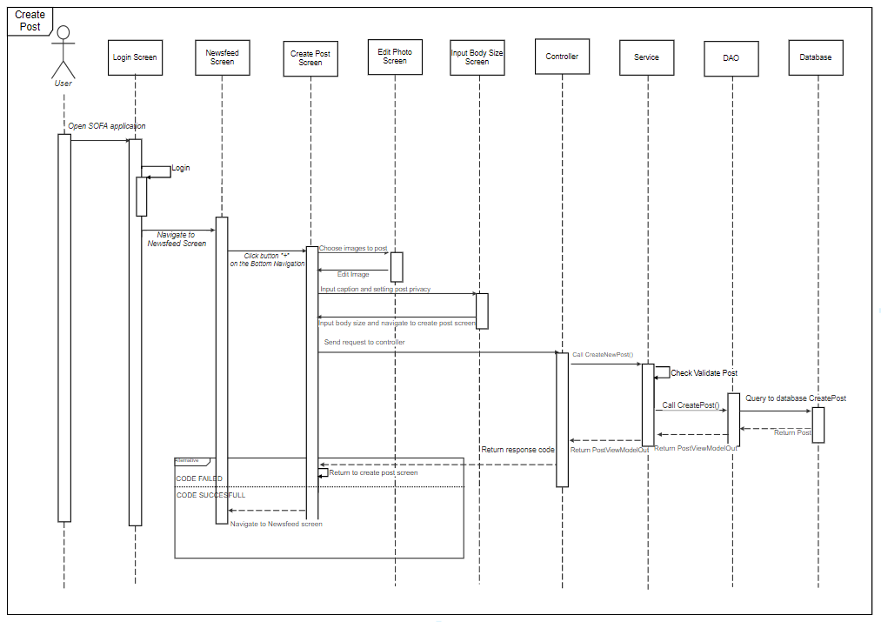

***7.2. View post detail***



***7.3. View edit post***

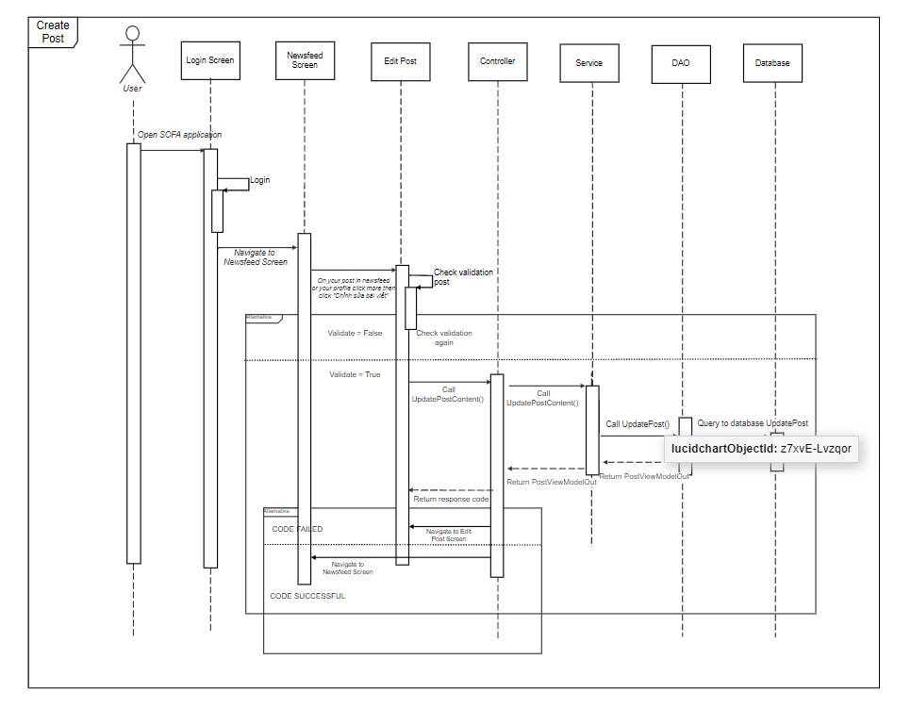

***7.4. Update Profile***



***7.5. Chat***

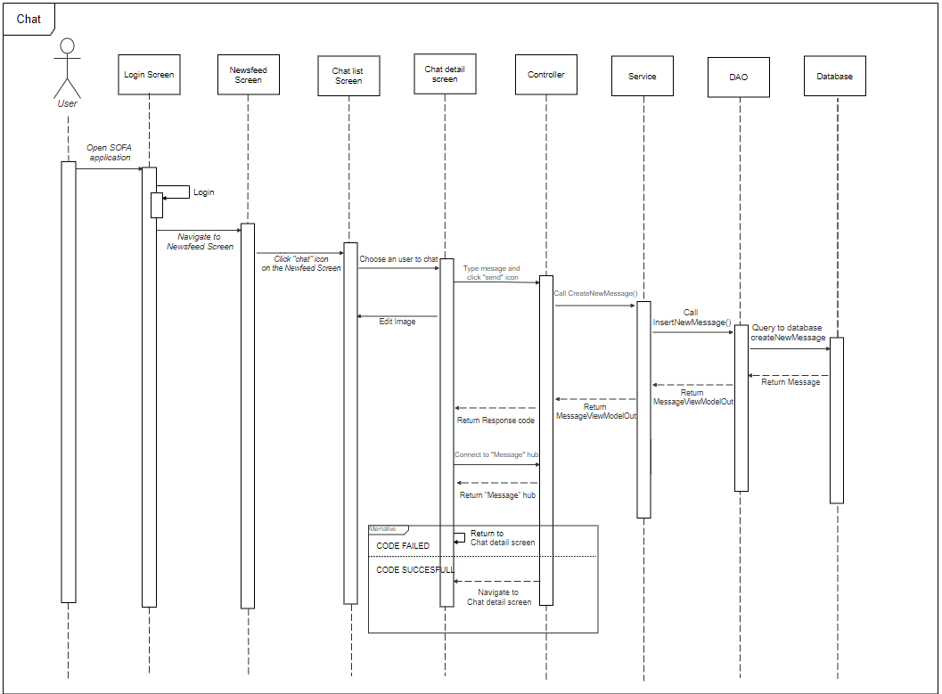

***7.6. Like Post***



## User Interface Design

## *8.1. Screen Image*

8.1.1 Login



8.1.2. Register



8.1.3. Newsfeed



8.1.4 Hot

## 

8.1.5 Recommend



8.1.6 Create Post



8.1.7. Post Detail



8.1.8 Search



8.1.9 Notification

8.1.10 Chat



8.1.11 Bookmark



8.1.12 Account



8.1.13 Profile



8.1.14 Edit Profile



8.1.15 Balance



## Database Design

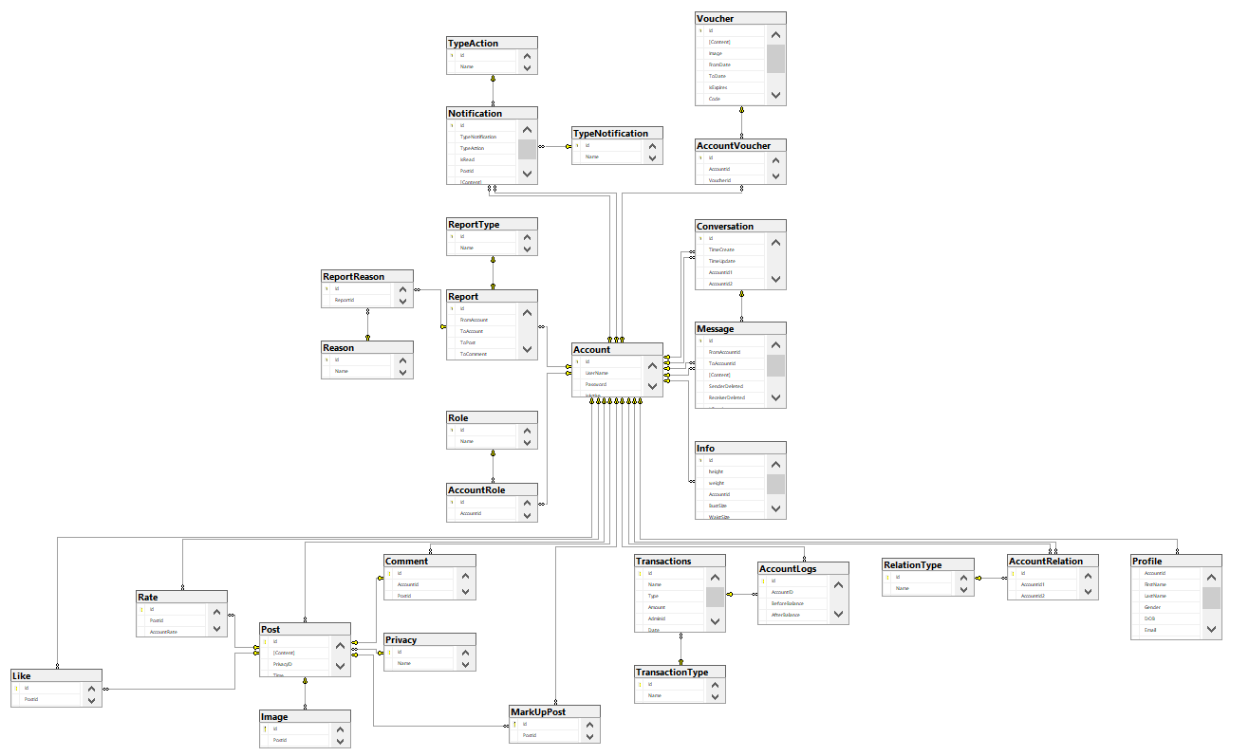

# Chapter 5: Software Test Documentation

## Purpose

The primary purpose of this chapter is to detect and prevent defects which may be created by developers while developing the software and this may lead to software failures. On the other hand, another objective of this chapter is to provide information about the level of quality and to make sure that the end result meets the business and user requirements. It contains the following sections:

* Test approach
* Test stages
* Test type
* Test plan: Feature to be tested, Feature not to be tested, Test process, Test schedule, Testing tool and environment.
* Test cases
* Checklist
* Test report

1. **Test Approach**



Overall, we choose V-Model to implement the testing process. With V-Model, software development is separated into two appropriate phase’s groups: development and testing. In this model, the verification and validation will be done side by side. It emphasizes the strict process flow to develop a quality product. The errors occurring in any phase will be corrected in that phase. Proactive defect tracking defects, which are found at early stages even, may be in the development phase before application being tested.

1. **Testing Types**

The test team has to test the following type on SOFA Application and Google Chrome:

* GUI test
* Function test
* Acceptance test
* Unit test

|  |  |  |  |
| --- | --- | --- | --- |
| **Type of test** | **Stage of test** | | |
| **Integration test** | **System test** | **Acceptance test** |
| Unit test | x | x |  |
| GUI test |  | x | x |
| Function test | x | x | x |
| Acceptance test |  | x | x |

## Test Plan

### 4.1 Test Stages

In this project, there are 3 phases in the testing process: Integration testing, System testing and Acceptance testing.

|  |  |  |
| --- | --- | --- |
| No. | Test Stages | Description |
| 1 | Integration testing | Integration testing allows individuals the opportunity to combine all of the units within a program and test them as a group. This testing level is designed to find interface defects between the modules/functions. This is particularly beneficial because it determines how efficiently the units are running together. |
| 2 | System testing | System testing is the first level in which the complete application is tested as a whole. The goal at this level is to evaluate whether the system has complied with all of the outlined requirements and to see that it meets Quality Standards. |
| 3 | Acceptance testing | Acceptance testing (or User Acceptance Testing), is conducted to determine whether the system is ready for release. During this phase, the tester and some alpha test users will test the system to find out whether the application meets their business’ needs. |

Table 5.1 – Testing stages

### 4.2 Resources

#### *a. Human Resources*

|  |  |  |
| --- | --- | --- |
| **Worker/Doer** | **Role** | **Specific Responsibilities/Comments** |
| VienMV |  | Make a Test plan, Create test reports |
| VanLT |  | Unit test |
| TungNT |  | Unit test |
| DungHV |  | System test |
| HoangNH |  | GUI test, System test |

#### *b. Environment*

* Chrome 84.0.4147.135 (64-bit) DevTools: To view logs, inspect elements, lighthouse.

*Figure 2.2.1 - Chrome dev tools*

* Google sheet: To manage test documents

*Figure 2.2.2 - Google sheet*

* Microsoft Visual Studio 17: To run unit tests and create/ update code unit tests.

*Figure 2.2.3 - Microsoft visual*

* Apache JMeter 5.4.1: To test performance



*Figure 2.2.4 - Jmeter*

* Trello: To log bug and manager task

**

*Figure 2.2.5 - Trello*

|  |  |  |
| --- | --- | --- |
| **Type of testing** | **Software** | **Hardware** |
| System test & Acceptance test & Test case | * Google Sheet. * Google Docs. * Google Chrome 84.0.4147.135 (64-bit) | Personal computer for developing with the minimum configuration:  - Laptop Asus  - 2.20GHz Intel Core i7  - RAM: 16GB  Personal mobile phone for run testing with configuration:   * Samsung galaxy note 10 * Os: android 9.0 (pie) * Chip: Exynos 9825 * Ram: 8GB |
| Unit test | * Microsoft Visual Studio 2017 | Personal computer for run testing with minimum configuration:   * Laptop Asus rog gl552vx * Core i7 6700HQ 2.6GHz * RAM: 8GB |
| Performance Test | * Apache Jmeter 5.4.1 | Personal computer for run testing with minimum configuration:   * Laptop Asus rog gl552vx * Core i7 6700HQ 2.6GHz * RAM: 8GB |

*Table 2.2.5 – Testing Environment*

### 4.3 Features to be tested

|  |  |  |
| --- | --- | --- |
| **ID** | **Use Case** | **Actors** |
| 01 | View newsfeed | Guest |
| 02 | Register | Guest |
| 03 | Login | Guest |
| 04 | Forgot password | User |
| 05 | Verification | User |
| 06 | Logout | User |
| 07 | View newsfeed | User |
| 08 | View post detail | User |
| 09 | Like post | User |
| 10 | Rate post | User |
| 11 | Comment post | User |
| 12 | Report post | User |
| 13 | Markup | User |
| 14 | Post a post | User |
| 15 | Update post | User |
| 16 | Delete post | User |
| 17 | Follow users | User |
| 18 | Unfollow users | User |
| 19 | Block users | User |
| 20 | Report users | User |
| 21 | View other user’s profile | User |
| 22 | Chat | User |
| 23 | Delete message in the conversation | User |
| 24 | Delete conversation | User |
| 25 | View list conversation | User |
| 26 | Search a conversation | User |
| 27 | View my profile | User |
| 28 | Update my profile | User |
| 29 | Search people | User |
| 30 | Search post | User |
| 31 | View list notification | User |
| 32 | View a notification | User |
| 33 | View hot posts | User |
| 34 | Recommend | User |
| 35 | Show suggest place of sale | User |
| 36 | View balance | User |
| 37 | Top up account | User |
| 38 | View list voucher | User |
| 39 | View voucher detail | User |
| 40 | Login | Manager |
| 41 | Logout | Manager |
| 42 | Create new staff | Manager |
| 43 | View list user | Manager |
| 44 | Search user | Manager |
| 45 | Ban user | Manager |
| 46 | Reset password for user | Manager |
| 47 | View list post | Manager |
| 48 | View post detail | Manager |
| 49 | Search user’s post | Manager |
| 50 | Delete post | Manager |
| 51 | Manage voucher | Manager |
| 52 | View list report | Manager |
| 53 | View report detail | Manager |
| 54 | Manage recommend data | Manager |
| 55 | Manage user’s balance | Manager |
| 56 | Manage my profile | Manager |

## 

### 4.4 Test process



* Test Planning and Control use requirement specification test plans will make more detailed decisions about the overall approach of testing.
* Test Analysis and Design design and create test cases.
* Test Implementation and Execution: execute test procedures using test execution tools, check actual results with expected results.
* Evaluating exit criteria and Reporting defines when to stop testing based on time.
* Test closure activities update Test Report and if there is an error then report error.

### 4.5 Test schedule

The table below describes the test schedule for the SoFa Project:

|  |  |  |  |
| --- | --- | --- | --- |
| **Test Schedule** | **Start Date** | **End Date** | **Responsibilities** |
| Unit test | April 04, 2021 | April 18, 2021 | TungNT, VanLT |
| GUI test | March 18, 2020 | March 22, 2020 | VienMV, HoangNH |
| System test | March 18, 2020 | April 29, 2021 | VienMV, HoangNH, DungHV |
| Acceptance test | April 18, 2021 | April 26, 2021 | User |

*Table 5.2 – Test schedule*

## Test Cases

Test cases have been managed on the [Test Case Sheet](https://drive.google.com/file/d/1X_9vBe1qs53Yzc2_xQe72vfOo2-Vw9uE/view?usp=sharing). These are some example images about the Test cases below:



*Figure 5.1 - Test case for change password*



*Figure 5.2 - Test case for function manager user*

## Checklists

|  |  |  |  |
| --- | --- | --- | --- |
| ID | Checklists | Yes | No |
|  | General |  |  |
| CL-01 | Functionality of buttons available on all screen, | √ |  |
| CL-02 | Validation error messages are displayed properly below the field. | √ |  |
| CL-03 | All numeric values are formatted properly. | √ |  |
| CL-04 | All error messages are displayed using red color. | √ |  |
| CL-05 | Delete functionality for any record on the page is asked for confirmation. | √ |  |
| CL-06 | Text does not have grammatical and spelling errors. | √ |  |
| CL-08 | Feature buttons on all page displays with the right role of users. | √ |  |
| CL-09 | All mandatory fields are validated and required. | √ |  |
|  | GUI and Usability |  |  |
| CL-10 | Information is presented in the order that the user needs it. | √ |  |
| CL-11 | All fields on page (e.g. text box, radio options, dropdown lists) should be aligned properly. | √ |  |
| CL-12 | The text is easy to understand. Don't use slang, acronyms, and abbreviations. | √ |  |
| CL-13 | Icons and images are designed to give impression and copyright. | √ |  |
| CL-14 | The most important fields are located where they are easy to see. | √ |  |
|  | Database |  |  |
| CL-15 | Input date of birth cannot be greater than current date. | √ |  |
| CL-16 | Null values are not allowed for Primary key columns. | √ |  |
| CL-17 | Radio button options are saved correctly in the database with true/false. | √ |  |
| CL-18 | Input data is not truncated. Field length shown to the user on page and in database schema should be the same. | √ |  |
| CL-19 | Input numeric fields with minimum, maximum, and float values. | √ |  |
| CL-20 | Input date is formatted dd/mm/yyyy | √ |  |
| CL-21 | Database fields are designed with correct data type and data length. | √ |  |
| CL-22 | Input field leading and trailing spaces are truncated before committing data to the database. | √ |  |
| CL-23 | Fields of columns are unique then cannot duplicate. | √ |  |
|  | Security |  |  |
| CL-24 | Test login with google authenticator. | √ |  |
| CL-25 | Do not save all information of the account logged, but only save user id in session. | √ |  |

*Table 5.3 – Checklist*

## Test Reports

* Test report has been manage on the [Test report sheet](https://docs.google.com/spreadsheets/d/1X_9vBe1qs53Yzc2_xQe72vfOo2-Vw9uE/edit#gid=1789090907)

# Chapter 6: Software User’s Manual

* + - 1. **Terms and definitions**

SOFA: (standing for **So**cial **Fa**shion) name of the application

* + - 1. **System requirements**
* Internet
* Android Environment
  + - 1. **Application Usage**

3.1 Overview

The system consists of two main parts:

- Application: This is a system (built on a social network model) that allows users to share and embrace fashion styles. The system has the functions of a social network and comes with functions to share and fashion suggestions. The basic features can be mentioned as:

+ *Authentication*

+ *Post*

*+ User Interact*

*+ Message*

*+ Balance*

+ *Hot*

+ *Recommend*

*+ Support/Feedback*

*+ Setting*

*+ Notification*

*+ Markup post*

- Web manager: This is the website used by administrators to manage the data of the system. For its purposes, the website has the following main features:

+ *Authentication*

*+ Dashboard*

*+ Post management*

*+ User management*

*+ Report management*

*+ Voucher management*

*+ Support management*

*+ Feedback management*

*+ Account management*

3.2 User Guidelines

3.2.1. Authentication (User)

-This feature is used by users to access the system to use advanced features or exit the system.

- Functions are used in this feature:

+ Login

+ Logout

+ Register

+ Forget password

***3.2.1.1. Function Login***

- Step 1: Access application



- Step 2: Click icon Account



- Step 3: Click “Đăng nhập”



***3.2.1.1.1. Login by username and password***

- Step 4_1: Input username and password



- Step 5_1: Click “Đăng nhập”



***3.2.1.1.2. Login by Google Account***

**-** Step 4_2: Click icon Google



**-** Step 5_2: Select Account



**-** Step 6_2: Click “Cho phép”



***3.2.1.2. Function Logout***

- Step 1: Click Icon Account



- Step 2: Click “Đăng xuất”



- Step 3: Click “Có”



***3.2.1.3. Function Register***

- Step 1: Click “Đăng kí”



**-** Step 2: Input phone number and click “Đăng kí”



- Step 3: Input OTP and click “Xác nhận”



- Step 4: Input information and click “Đăng kí”



- Step 5: Click “OK”



***3.2.1.4. Function Forget Password***

- Step 1: Click “Quên mật khẩu”



- Step 2: Input “Phone number” and click “Xác nhận”



- Step 3: Input OTP and click “Xác nhận”



- Step 4: Input New password and click “Xác nhận”



- Step 5: Click “OK”



#### 3.2.2. Post (User)

-This feature is used by users to access the system to perform interactions with the posts.

- Functions are used in this feature:

+ View list post

+ View post detail

+ Like post

+ Rate post

+ Comment post

+ Markup post

+ Report post

+ Create post

***3.2.2.1. View list post (In New feed)***

- Step 1: Access application

 

***3.2.2.2. View post detail***

- Step 1: Click a post’s header

 

***3.2.2.3. Like a post***

- Step 1: Click icon “Like”

*** ***

***3.2.2.4. Rate a post***

- Step 1: Slide the rating bar

 

***3.2.2.5. Comment a post***

- Step 1: Click icon “Comment”



- Step 2: Comment something



- Step 3: Click icon “Send”

 

***3.2.2.6. Markup a post***

- Step 1. Click icon “More”



- Step 2: Click “Lưu bài viết”

- 

***3.2.2.7. Report a post***

- Step 1. Click icon “More”



- Step 2: Click “Báo cáo bài viết này”



***3.2.2.8. Create a new post***

- Step 1: Click icon “Add” in navigation



- Step 2: Click “Nhắc lại sau”/”Không nhắc lại”



-Step 3: Choose “Privacy”

 

-Step 4: Choose type of post

 

-Step 5: Input status



- Step 6: Choose picture

 

-Step 7: Click “Đăng”



-Step 8: Choose set of measurement



-Step 9: Click “Đăng”



#### 3.2.3. Hot (User)

-This feature is used by users to see hot posts of fashionista.

- Functions are used in this feature:

+ View list hot post

+ All function like post(User)

***3.2.3.1. View list hot post***

-Step 1: Access application



-Step 2: Click icon “Hot”



***3.2.3.1. Other function like Post (User)***

*Direct to 3.2.2*

#### 3.2.4. Recommend (User)

-This feature is used by users to see recommend posts of fashionista.

- Functions are used in this feature:

+ View list recommend posts

+ All function like post(User)

***3.2.4.1. View list recommend post***

-Step 1: Access application



-Step 2: Click icon “Recommend”



-Step 3: Click “Chọn bộ số đo”



- Step 4: Choose a set of measurement



- Click “Chọn”



***3.2.4.2. Other function like Post (User)***

*Direct to 3.2.2*

***3.2.5. User Interact (User)***

-This feature is used by users to interact with other users .

- Functions are used in this feature:

+ View other’s profile

+ Follow user

+ Report user

+ Message to other user

***3.2.5.1. View other’s profile***

- Step 1: Click user’s avatar

 

***3.2.5.2. Follow user***

***3.2.5.2.1. Through newfeed***

- Step 1: Click icon “More”



-Step 2: Click “Theo dõi”



***3.2.5.2.1. Through other profile***

- Step 1: Click “Follow”



***3.2.5.3. Report user***

- Step 1. Click icon “More”



- Step 2. Click “Báo cáo”



- Step 3. Select reason and click icon “Done”



***3.2.5.4. Message to other user***

- Step 1: Click button “Message”



-Step 2: Type message and click icon “Send”

 

***3.2.6. Support/Feedback (User)***

-This feature is used by users to send a support request or feedback to adminstrator .

- Functions are used in this feature:

+ Send feedback

+ View list feedback

+ View a feedback’s detail

+ Send support request

+ View support request’s result

***3.2.6.1. Send feedback***

- Step 1: Click icon “Account”



- Step 2: Click “Phản hồi và thắc mắc”



-Step 3: Click “Gửi feedback”



-Step 4: Input “Tiêu đề” and “Nội dung” and click “Gửi”



***3.2.6.2. View list feedback***

- Step 1: Click icon “Account”



-Step 2: Click “Phản hồi và thắc mắc”

 

***3.2.6.3. View feedback’s detail***

- Step 1: Click a feedback

 

***3.2.6.4. Send support request***

- Step 1: Click icon “Account”



-Step 2: Click “Hỗ trợ”



-Step 3: Choose type of support request



***3.2.6.4. View support request’s detail***

-Step 1: Choose type of support request (after sent a request)

 

***3.2.7. Message (User)***

-This feature is used by users to chat with other user .

- Functions are used in this feature:

+ View conversation list

+ View a conversation

+ Delete a conversation

+ Create new message

+ Delete a message

***3.2.7.1. View conversation list***

- Step 1: Click icon “Message”

 

***3.2.7.2. View a conversation***

- Step 1: Click a conversation

 

***3.2.7.3. Delete a conversation***

- Step 1: Slide a conversation to the left



-Step 2: Click button “Xóa”

 

***3.2.7.4. Create new message***

***3.2.7.4.1. Create new message through other profile***

-Step 1: Click button “Message”



-Step 2: Type a message and click icon “Send”

 

***3.2.7.4.2. Create new message through message screen***

-Step 1: Type a message and click icon “Send”

 

***3.2.7.4.3. Create new message through conversation screen***

-Step 1: Click icon “New”



-Step 2: Choose a user



-Step 3: Type a message and click icon Send

 

***3.2.7.5. Delete a message***

-Step 1: Hold a message



-Step 2: Click “Xóa tin nhắn”

 

#### 3.2.8. Markup post (User)

-This feature is used by users to manage markup post.

- Functions are used in this feature:

+ Markup a post

+ View markup post list

+ View markup post detail

***3.2.8.1. Function Markup a post***

- Step 1: Click “More” icon



-Step 2: Click “Lưu bài viết”

 

***3.2.8.2. View markup post list***

- Step1: Click icon “Account”



-Step 2: Click “Xem bài viết đã lưu”

 

***3.2.8.2. View markup post’s detail***

- Step 1: Click a post

 

#### 3.2.9. Balance (User)

-This feature is used by users to manage balance.

- Functions are used in this feature:

+ View balance

+ Topup balance (pending)

+ View vourcher

***3.2.9.1. View balance***

- Step 1: Click icon “Account”



-Step 2: Click “Xem số dư tài khoản”

 

***3.2.9.2. View voucher***

- Step 1: Click button “View voucher”



***3.2.9.3. Topup balance***

- Step 1: Click button “Topup”



#### 3.2.10. Notification (User)

-This feature support user to view list notification and allow user to view detail notification if they click on that notification.

- Functions are used in this feature:

+ View list notification

+ View detail notification

+ Mark all as read

***3.2.10.1. Function View list notification***

Step 1: Access the application



Step 2: On newsfeed click on icon “Notification”



Step 3: View the list notification



***3.2.10.2. Function View notification detail***

Step 1: On Notification screen, click on one notification on the list



Step 2: View the post detail which send notification to user



***3.2.10.3. Function Mark all notification as read***

Step 1: On Notification screen, click on “Đánh dấu tất cả đã đọc”



Step 2: View the list notification that all notifications are mark as read



#### 3.2.11. Body measurement (User)

-This feature support user to view list body measurement and manage its

- Functions are used in this feature:

+ View list body measurement

+ View detail body measurement

+ Delete body measurement

***3.2.11.1. Function View list body measurement***

Step 1: Access the application



Step 2: On the newsfeed screen, click on “Account”



Step 3: On the “account” screen, click on “Chỉ số cá nhân”



Step 4: View list body measurement



***3.2.11.2. Function View detail body measurement***

Step 1: On the list “Chỉ số cá nhân” screen, click on “Bộ chỉ số 1”



Step 2: View detail of body measurement name “Bộ chỉ số 1”



***3.2.11.3. Function Delete body measurement***

Step 1: On detail of body measurement name “Bộ chỉ số 1” screen, click on button “Xóa”



Step 2: Back to the body measurement list to view “Bộ chỉ số 1” is deleted



#### 3.2.12. Setting (User)

-This feature support user setting about account, notification and display

- Functions are used in this feature:

+ Change Password

+ Turn on/off notification

+ Change message theme

***3.2.12.1. Function Change Password***

Step 1: On the “account” screen, click on “Cài đặt chung”



Step 2: On the “setting” screen, click on “Đổi mật khẩu”



Step 3: On “Đổi mật khẩu” screen, input old password, new password, re-enter new password then clicks on “Xác nhận” then the password is changed



***3.2.12.2. Function Turn on/off notification***

Step 1: On “Settings” screen, swipe to right to turn on the notification and swipe to left to turn off notification



***3.2.12.3. Function Change message theme***

Step 1: On “Settings” screen, click on “Chủ đề tin nhắn”



Step 2: On popup, choose the color which you want to change to



#### 

#### 3.2.13. Authentication (Administrator)

-This feature is used by administrator to access the system to manage data of the system.

- Functions are used in this feature:

+ Login

+ Logout

+ Create new staff

***3.2.13.1. Function Login***

- Step 1: Access https://sofamanagement.com/login

If you have not login yet, access https://sofamanagement.com, the system redirect to login page, require login first



- Step 2: Input Username, Password and click “Login”



***3.2.13.2. Function logout***

- Step 1: Access <https://sofamanagement.com>, require that you had loged in before



- Step 2: Click on “Logout”



***3.2.13.3. Function create new staff***

- Step 1: Access <https://sofamanagement.com>, require that you had loged in before



- Step 2: Click on “Create new staff”





- Step 3: Input required information and click “Register”



#### 3.2.14. Dashboard (Administrator)

This feature is used by administrator to view the general information data of system.

- Step 1: Access <https://sofamanagement.com>, require that you had loged in before, if you access from login page, system will redirect to Dashboard page



- Step 2: Click on “Dashboard” on left navigation



#### 3.2.15. User management (Administrator)

*-* This feature is used by administrator to manage user that using the SOFA app

- Functions are used in this feature:

+ View user list

+ Search user

+ View user detail

+ Ban user

+ Reset password for user

+ Add balance for user

***3.2.15.1. Function View user list***

- Step 1: Access <https://sofamanagement.com>, require that you had loged in before



- Step 2: Click on “User” on left navigation





***3.2.16.2. Function Search user***

- Step 1: Access <https://sofamanagement.com>, require that you had loged in before



- Step 2: Click on “User” on left navigation





- Step 3: Input keyword to search, you can search user by username, fullname, email, phone



***3.2.16.3. Function View user detail***

- Step 1: Access <https://sofamanagement.com>, require that you had loged in before



- Step 2: Click on “User” on left navigation





- Step 3: Click on “detail” of a record in table





***3.2.16.4. Function Ban user***

- Step 1: Access <https://sofamanagement.com>, require that you had loged in before



- Step 2: Click on “User” on left navigation





- Step 3: Click on “detail” of a record in table



  
- Step 4: Click on “Ban” button on the right and click “OK” confirm





***3.2.16.4. Function Unban user***

- Step 1: Access <https://sofamanagement.com>, require that you had loged in before



- Step 2: Click on “User” on left navigation





- Step 3: Click on “detail” of a record in table





- Step 4: Click on “Unban” button on the right and click “OK” confirm





***3.2.16.5. Function Reset password for user***

- Step 1: Access <https://sofamanagement.com>, require that you had loged in before



- Step 2: Click on “User” on left navigation





- Step 3: Click on “detail” of a record in table





- Step 4: Click on “Reset password” button on the right and click “OK” confirm





***3.2.16.6. Function Add balance for user***

- Step 1: Access <https://sofamanagement.com>, require that you had loged in before



- Step 2: Click on “User” on left navigation





- Step 3: Click on “detail” of a record in table





- Step 4: Click on “Add balance” button on the right and input balance and click “Ok” confirm





#### 3.3.17. Feature User management (Adminstrator)

*-* This feature is used by administrator to manage post that posted by user that using the SOFA app

- Functions are used in this feature:

+ View post list

+ Search post

+ View post detail

+ Delete post

***3.2.17.1. Function View post list***

- Step 1: Access <https://sofamanagement.com>, require that you had loged in before



- Step 2: Click on “Post” on left navigation



***3.2.17.2. Function View post detail***

- Step 1: Access <https://sofamanagement.com>, require that you had loged in before



- Step 2: Click on “Post” on left navigation



- Step 3: Click on “detail” of a record in table





***3.2.17.3. Function Search post***

- Step 1: Access <https://sofamanagement.com>, require that you had loged in before



- Step 2: Click on “Post” on left navigation



- Step 3: Input keyword to search, you can search user by posted by, content



***3.2.17.4. Function Delete post***

- Step 1: Access <https://sofamanagement.com>, require that you had loged in before



- Step 2: Click on “Post” on left navigation



- Step 3: Click on “detail” of a record in table





- Step 4: Click on “Delete” button on the right and click “OK” confirm





#### 3.2.18. Feature Report management (Administrator)

*-* This feature is used by administrator to manage report that reported by user that using the SOFA app

- Functions are used in this feature:

+ View report list

#### 3.2.18.1. Function View report list

- Step 1: Access <https://sofamanagement.com>, require that you had loged in before



- Step 2: Click on “Report” on left navigation



#### 3.2.19. Feature Voucher management (Administrator)

*-* This feature is used by administrator to manage voucher that created by user that using the SOFA app

- Functions are used in this feature:

+ View voucher list

+ Search voucher

+ Delete voucher

#### 3.2.19.1. Function View voucher list

- Step 1: Access <https://sofamanagement.com>, require that you had loged in before



- Step 2: Click on “Voucher” on left navigation



#### 3.2.19.2. Function Search voucher

- Step 1: Access <https://sofamanagement.com>, require that you had loged in before



- Step 2: Click on “Voucher” on left navigation



- Step 3: Input keyword to search, you can search user by title, content, code, created by



#### 3.2.19.3. Function Delete voucher

- Step 1: Access <https://sofamanagement.com>, require that you had loged in before



- Step 2: Click on “Voucher” on left navigation



- Step 3: Click on “delete” of a record in table and click “OK” confirm





#### 3.2.20. Feature Support management (Administrator)

*-* This feature is used by administrator to manage support that requested by user that using the SOFA app

- Functions are used in this feature:

+ View support list

+ Search support

+ Approve support

+ Reject support

***3.2.20.1. Function View support list***

- Step 1: Access <https://sofamanagement.com>, require that you had loged in before



- Step 2: Click on “Support” on left navigation



#### 3.2.20.2. Function Search support

- Step 1: Access <https://sofamanagement.com>, require that you had loged in before



- Step 2: Click on “Support” on left navigation



- Step 3: Input keyword to search, you can search user by username, email, fullname, phone



#### 3.2.20.3. Function Approve support

- Step 1: Access <https://sofamanagement.com>, require that you had loged in before



- Step 2: Click on “Support” on left navigation



- Step 3: Click on “Approve” on record of table and click “OK” confirm



#### 3.2.20.4. Function Reject support

- Step 1: Access <https://sofamanagement.com>, require that you had loged in before



- Step 2: Click on “Support” on left navigation



- Step 3: Click on “Reject” on record of table and click “OK” confirm



#### 3.2.21. Feature Feedback management (Administrator)

*-* This feature is used by administrator to manage feedback that send by user that using the SOFA app

- Functions are used in this feature:

+ View feedback list

+ Search feedback

+ Accept feedback

***3.2.21.1. Function View feedback list***

- Step 1: Access <https://sofamanagement.com>, require that you had loged in before



- Step 2: Click on “Feedback” on left navigation



#### 3.2.21.2. Function Search feedback

- Step 1: Access <https://sofamanagement.com>, require that you had logged in before



- Step 2: Click on “Feedback” on left navigation



- Step 3: Input keyword to search, you can search user by send by, title, content



#### 3.2.21.3. Function accept support

- Step 1: Access <https://sofamanagement.com>, require that you had loged in before



- Step 2: Click on “Support” on left navigation



- Step 3: Click on “Accept” on record of table and click “OK” confirm



#### 3.2.22. Feature Account management (Administrator)

*-* This feature is used by administrator to manage own account

- Functions are used in this feature:

+ View my profile

+ Change password

#### 3.2.22.1 Feature View my profile

- Step 1: Access <https://sofamanagement.com>, require that you had loged in before



- Step 2: Click on “Avatar” icon on left navigation





#### 3.2.22.2 Feature Change my password

- Step 1: Access <https://sofamanagement.com>, require that you had logged in before



- Step 2: Click on “Avatar” icon on left navigation





- Step 3: Click on “Change password” button, input and click “Save”

